WORLD OF DASM

MEMORY GAME
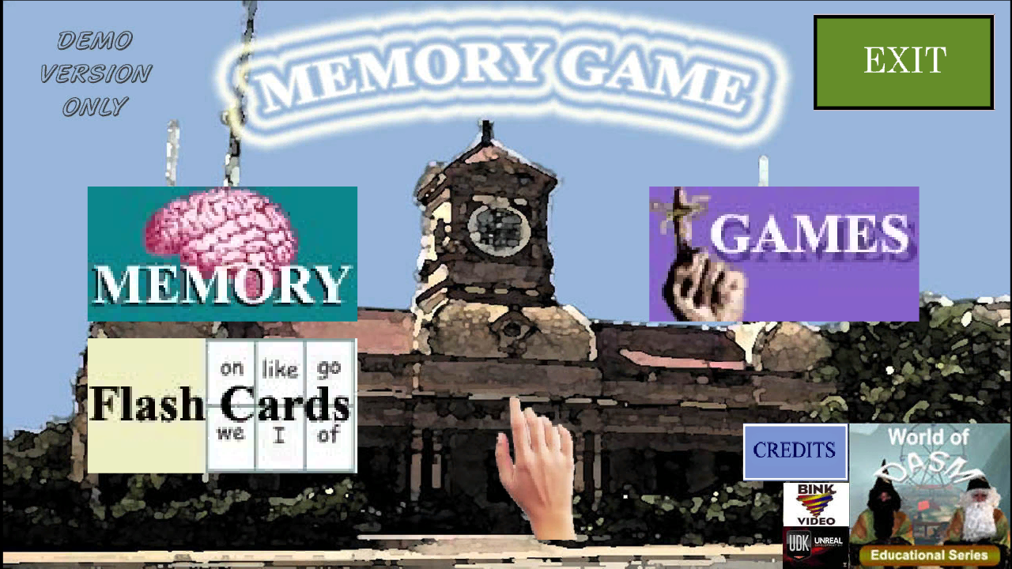
Created by Shane Hillier
www.worldofdasm.com
USER GUIDE

PC Specifications.
The World of DASM is a very “graphical game” and requires a decent or reasonably powerful PC to run the software. If you fall under the minimum specifications, the game will run very poorly or not at all.
Minimum.
Operating System: Windows XP.
CPU: 3Gb Duo Core Processor or similar.
PC Ram: 1Gb
Graphics Card: GT9800 with 512Mb Ram or above.
Hard Drive Space: 1.2Gb
Microsoft.NET
1024x768 Best Graphics setting.
Recommended.
Operating System: Windows XP, Vista, Windows7
CPU: Quad Core Processor Q6600+ or above.(2.4Gb)
PC Ram: 3Gb+
Graphics Card: GeForce GTX460 with 1Gb Ram or above.
Hard Drive Space: 1.2Gb
Microsoft.NET
1024x768 Best Graphics setting.
User Guide.
Installation.
Double click the file: World_of_DASM_Memory_game
First, you will have to agree with the agreement if you wish to install.
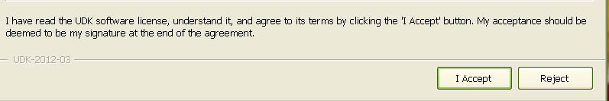
World of DASM Memory Game will practically install itself in its own default folder. If you wish, choose your own directory if needed. Then select Install.
Below is the default directory.
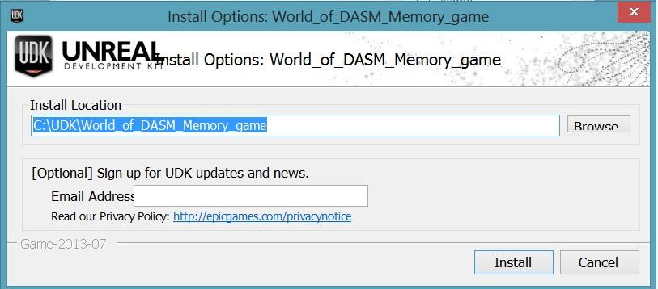
Note*(If you are interested in UDK and any of it features, you have the option of adding your e-mail address but it is not necessary.)

Simply click Finished to play. If you do not wish to play for now, untick Launch World of DASM Memory Game.
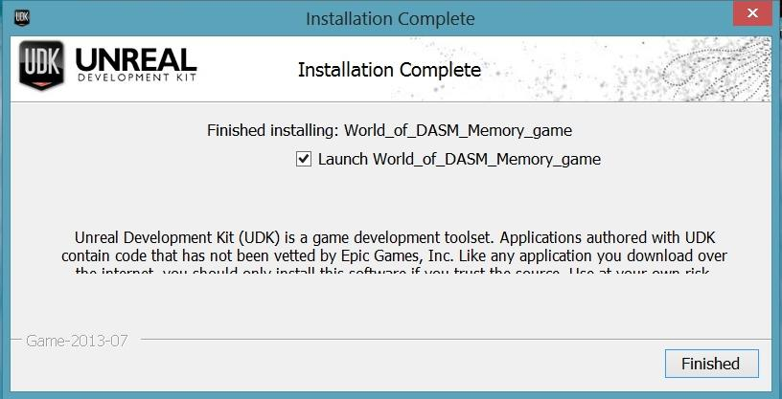
A shortcut will be placed in your “All Programs” List (Win XP )
Press the windows Key and your shortcut should be located in the first loading screen. (Windows 8)

Main Menu.(DEMO VERSION)
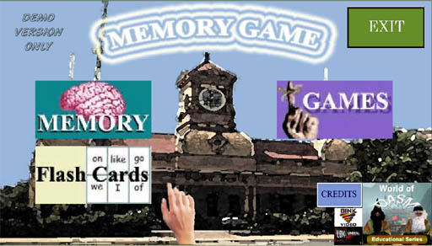
The menu contains 5 Buttons.
CREDITS: Says who created the game with the software used.
MEMORY: Remembering multiple words and locating them. (Not available in DEMO version)
GAMES: Look at a picture and remembering what was in it. (There are 2 maps that can be played, DEMO version is limited.)
EXIT: Exits Game
FLASH CARDS: Choose between two, three and four letter words on flash cards. (DEMO has full version of this feature.)
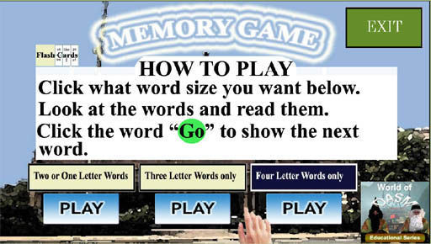
Pick two, three or four letter words.
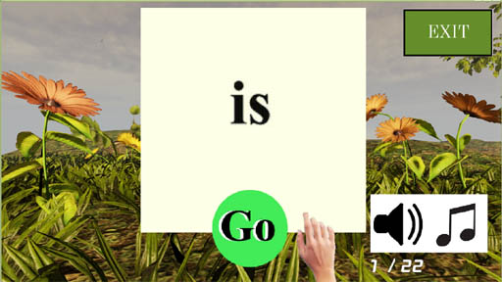
There are three buttons to press.
EXIT: Exit back to main menu
Go: selects the next word.
Sound Icon: This allows you to hear what word is on display.

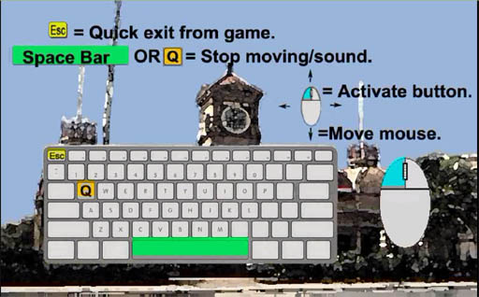
Interface
Space bar or Q=stop movement
Esc= Exit game you are in. (Does not work in the main Menu only works during game play.)
Mouse and left mouse button= Movement and select buttons.
Since this is a DEMO this is a brief manual. A more detailed version of this manual will be available Jan 2015 at www.worldofdasm.com

